**1) Define a protocol?**

Protocol, in computer science, a set of rules or procedures for transmitting data between electronic devices, such as computers. In order for computers to exchange information, there must be a preexisting agreement as to how the information will be structured and how each side will send and receive it.

**2) What is an IP address?**

An Internet Protocol address (IP address) is a numerical label such as 172.16.254.1 that is connected to a computer network that uses the Internet Protocol for communication. An IP address serves two main functions: host or network interface identification and location addressing.

**3) Explain about various transmission modes? Simplex, Half – duplex, Full-duplex?**

Data Transmission mode defines the direction of the flow of information between two communication devices. It is also called Data Communication or Directional Mode. It specifies the direction of the flow of information from one place to another in a computer network.

The data transmission modes can be characterized in the following three types based on the direction of exchange of information:

**Simplex** - Simplex is the data transmission mode in which the data can flow only in one direction, i.e., the communication is unidirectional. In this mode, a sender can only send data but can not receive it. Similarly, a receiver can only receive data but can not send it. It is mainly used in the business field as in sales that do not require any corresponding reply. It is similar to a one-way street.

**For Example**, Radio and TV transmission, keyboard, mouse, etc.

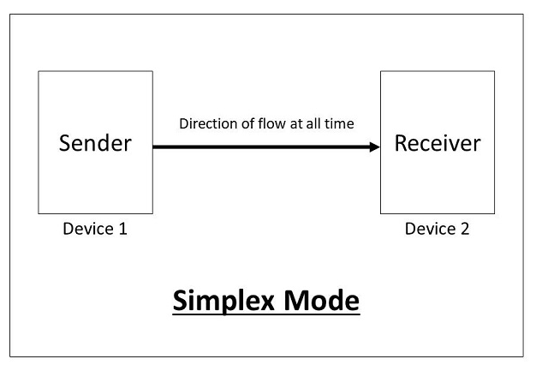

**Advantages of using a Simplex transmission mode:**

* It utilizes the full capacity of the communication channel during data transmission.
* It has the least or no data traffic issues as data flows only in one direction.

**Disadvantages of using a Simplex transmission mode:**

* It is unidirectional in nature having no inter-communication between devices.
* There is no mechanism for information to be transmitted back to the sender(No mechanism for acknowledgement).

**Half-Duplex** - Half-Duplex is the data transmission mode in which the data can flow in both directions but in one direction at a time. It is also referred to as Semi-Duplex. In other words, each station can both transmit and receive the data but not at the same time. When one device is sending the other can only receive and vice-versa.

In this type of transmission mode, the entire capacity of the channel can be utilized for each direction. Transmission lines can carry data in both directions, but the data can be sent only in one direction at a time.

This type of data transmission mode can be used in cases where there is no need for communication in both directions at the same time. It can be used for error detection when the sender does not send or the receiver does not receive the data properly. In such cases, the data needs to be transmitted again by the receiver.

**For Example**, Walkie-Talkie, Internet Browsers, etc.

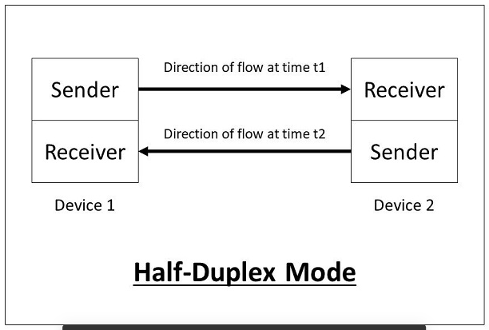

**Advantages of using a half-duplex transmission mode:**

* It facilitates the optimum use of the communication channel.
* It provides two-way communication.

**Disadvantages of using a half-duplex transmission mode:**

* The two-way communication cannot be established simultaneously at the same time.
* Delay in transmission may occur as only one way communication can be possible at a time.

**Full Duplex-** Full-Duplex is the data transmission mode in which the data can flow in both directions at the same time. It is bi-directional in nature. It is two-way communication in which both the stations can transmit and receive the data simultaneously. Full-Duplex mode has double bandwidth as compared to the half-duplex. The capacity of the channel is divided between the two directions of communication. This mode is used when communication in both directions is required simultaneously.

For Example, a Telephone Network, in which both the persons can talk and listen to each other simultaneously.

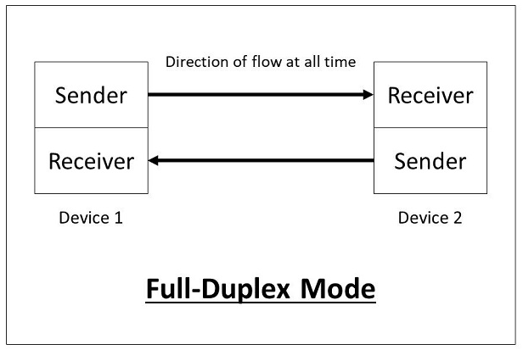

**Advantages of using a full-duplex transmission mode:**

* The two-way communication can be carried out simultaneously in both directions.
* It is the fastest mode of communication between devices.

**Disadvantages of using a half-duplex transmission mode:**

* The capacity of the communication channel is divided into two parts. Also, no dedicated path exists for data transfer.
* It has improper channel bandwidth utilization as there exist two separate paths for two communicating devices.

The data transmission modes can be characterized in the following two types based on the synchronization between the transmitter and the receiver:

Synchronous

Asynchronous

The data transmission modes can be characterized in the following two types based on the number of bits sent simultaneously in the network:

Serial

Parallel